Super Heroes!
Whilst the activities are themed they are fully adaptable to cater for and challenge any younger or older children attending. Other indoor and outdoor activities are available. We are led by the children on their interests with activities they enjoy. Your children’s enjoyment is very important to us and feedback is gratefully received.

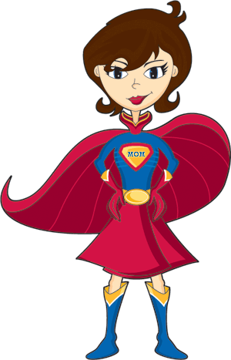
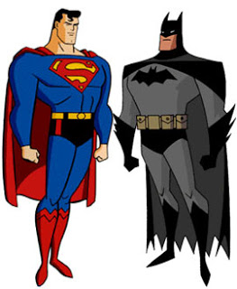

This Photo by Unknown Author is licensed under CC BY-NC
29th October – 2nd November 2018
Monday | Tuesday | Wednesday | Thursday | Friday
Am  Create a flying Super Hero  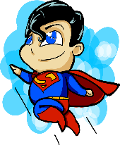  This Photo by Unknown Author is licensed under CC BY-SA-NC | Visit from Super Cake maker who will be visiting to make Super Hero Cakes!  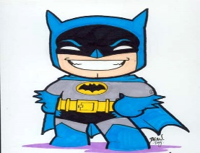  This Photo by Unknown Author is licensed under CC BY-NC-ND | Make Super Hero Cuffs  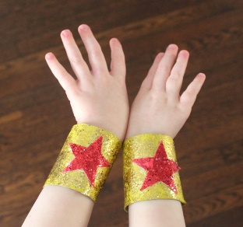  This Photo by Unknown Author is licensed under CC BY-SA-NC | Create Super Hero gliders and have a flying race | Visit from Sian, our Forest School practitioner to do some fun outdoor activities
Pm  Make a Super Hero city picture  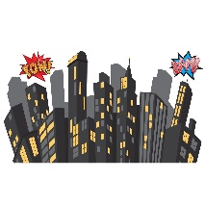 | Create Super Hero Cone characters  This Photo by Unknown Author is licensed under CC BY-SA-NC | Make Super Hero masks  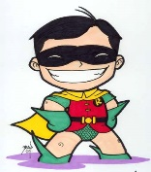  This Photo by Unknown Author is licensed under CC BY-NC-ND | Make a Super Hero puppet  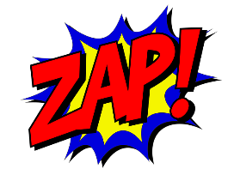 | Film afternoon with cinema treats  ‘The Incredibles’  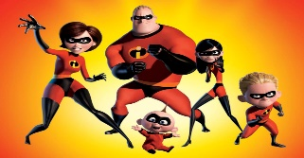  This Photo by Unknown Author is licensed under CC BY
