February Holiday Club 2017
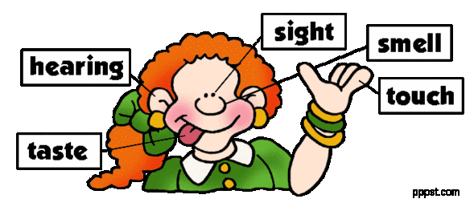
Please note whilst the activities are focused on our topics they are not exhaustive. There will be a selection of indoor and outdoor activities and we welcome any suggestions or ideas.

20th – 24th February
Symphony of the Senses
Monday | Tuesday | Wednesday | Thursday | Friday
Am Touch  Visit from the animal lady | Taste  Test your taste buds!  Make ‘no bake’ honeycombe crunchie fudge | Sight  Full day trip to the Red Carpet Theatre to see  ‘Sing’  £5.00 additional cost | Sound  Make musical instruments and conduct your own orchestra | Smell  Blindfold smell challenge
Pm  Let’s get messy and make seed bombs!  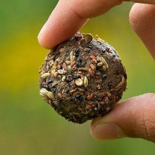 | Exploring taste activity: Sweet, sour, salty and bitter | Use your observational skills and play a game of charades | Try our ‘Don’t ring the bells’ obstacle course | Make homemade bath bombs

